Name:  Class: | ____________________________________  ________________ |  | Date:_________
 | Year 11 Foundations Mathematics  $\frac{ }{25}$  Test 3 - 2019  Topic – Addition of Whole Number and Money
Total Time: | 35 minutes
Weighting: | 3%
Equipment: | None

SHOW ALL YOUR WORKING OUT!

Question 1 9 marks

Complete the following addition squares:

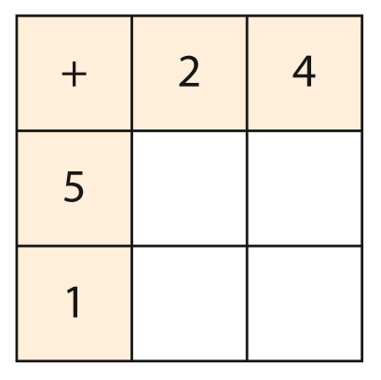 | 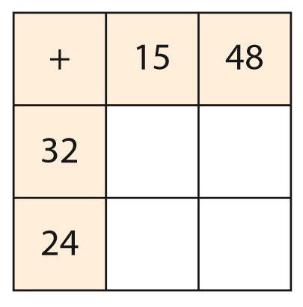
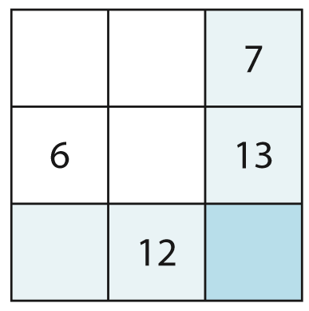 | 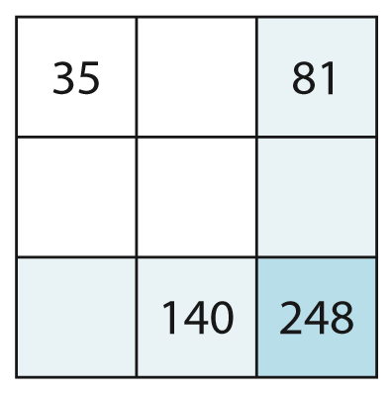

Question 2 8 marks

Complete the following sums:

- 257 + 17 = | - 3 482 + 394 =
- $275.8 + $50 = | - $0.36 + $172.46 =

Question 3 8 marks

- If there are seven erasers in a box and Laura puts thirty-one more erasers inside, how many erasers are in the box?

- Timothy starts with seventy-five cards. He gets two hundred and fifty-six more from Michael. How many cards does Timothy end with?

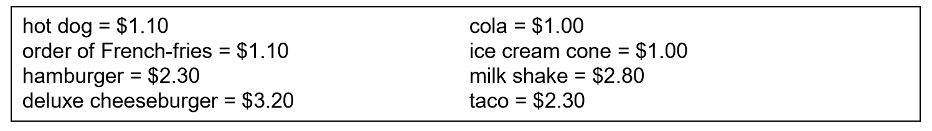
- What is the total cost of a cola and three hot dogs?

- What is the total cost of a deluxe cheeseburger, two fries and three milk shakes?

